Repeater format –

1. Display data in row format.

Repeater event handling –

1. Inside the repeater cannot use on click event.
2. Inside the repeater only use command name event.

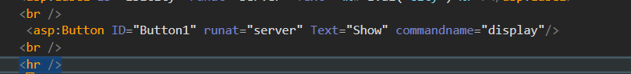

How to activate command name –

Activate command name inside the repeater using OnItemCommand attribute.



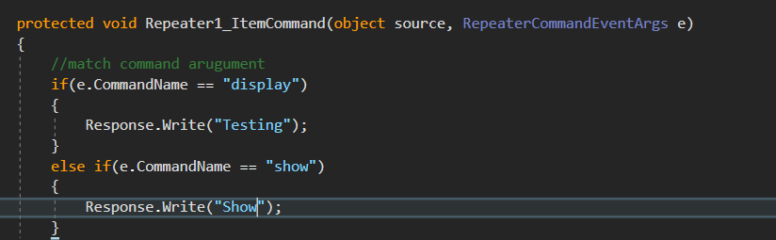

Find syntax – control ob = (control)row.ob

How to Find control inside repeater (inside if)

Syntax - Control ob = (control)e.item.findcontrol(“control_id”);

Ex – label obname = (label)e.item.findcontrol(“lblName”);

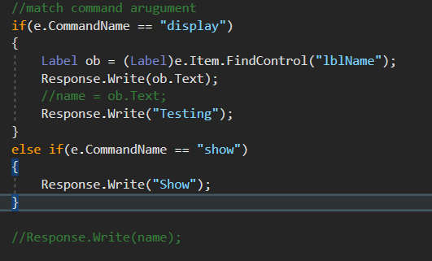

Perform event handling outside the control.

Using for loop

Syntax - control ob_name = (repeater1).Items[i].Findcontrol(“control_id”) as control;

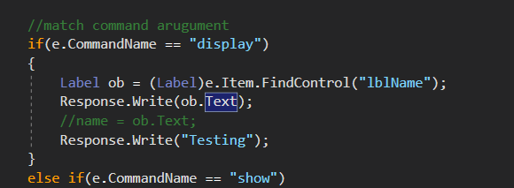

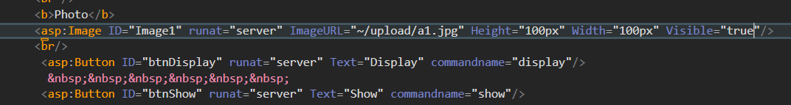

Assignment –

Design the concept of submit review.

Review.aspx

Name

Email

Mobile

Subject

Rank – Drop down List (1, 2, 3, 4)

Button Submit -

Button Show Review – create repeater control

1. Name
2. Email
3. Mobile
4. subject
5. Rank - ****